**Elastic Block Store (EBS)**

In AWS, Elastic Block Store (EBS) is a scalable, high-performance block storage service designed for use with Amazon EC2 (Elastic Compute Cloud) instances.

EBS volumes act like hard drives in the cloud, providing reliable and persistent storage that remains even if the instance is stopped or restarted.

**TASK: How to retrieve a file from a deleted volume back to the instance through a snapshot of a deleted volume.**

**STEP 1: Create an Instance**

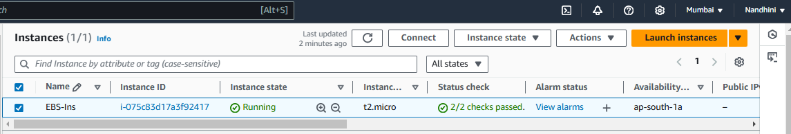

**STEP 2: Create volume with the size of 2GB and attach it to EBS instance.**

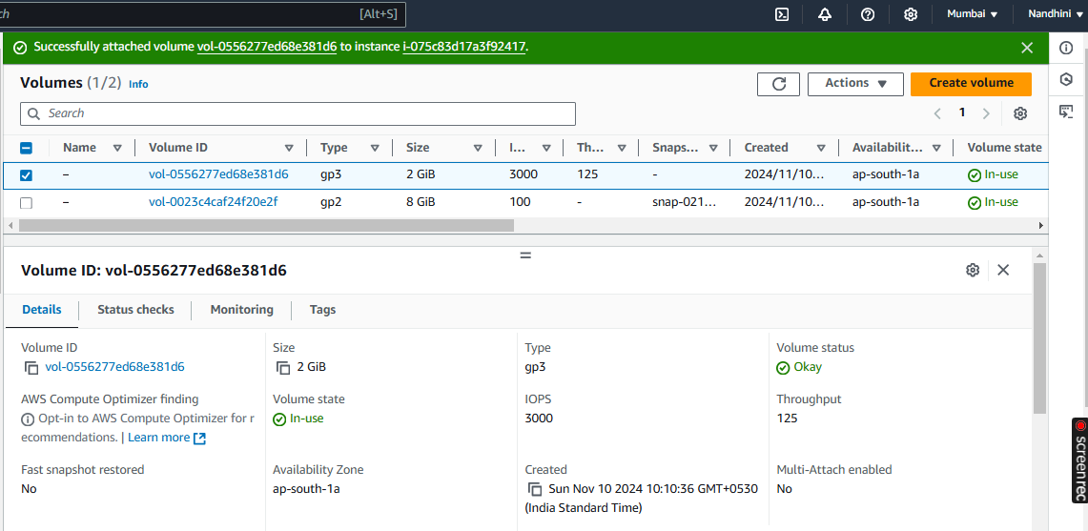

**STEP 3: Login to EBS instance and check for the list of block and mount the volume.**

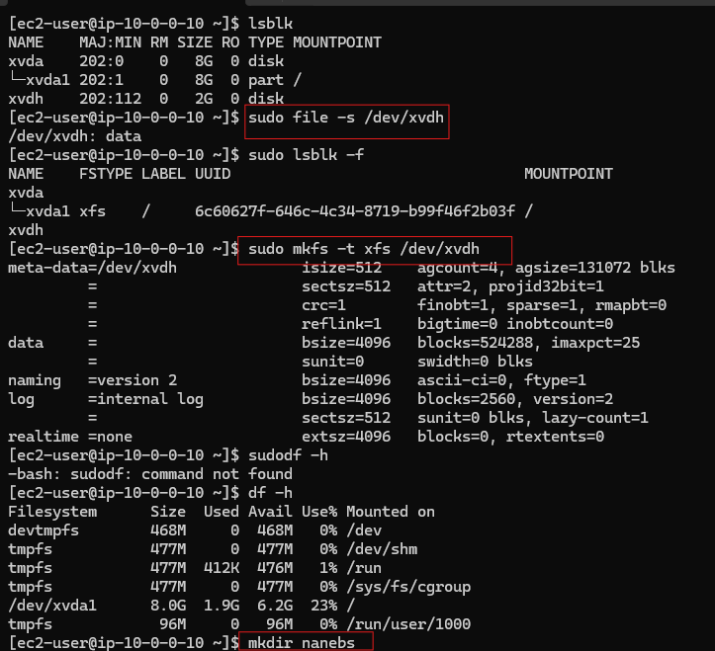

**Step 4: Create a folder and mount the volume, then create sample txt file.**

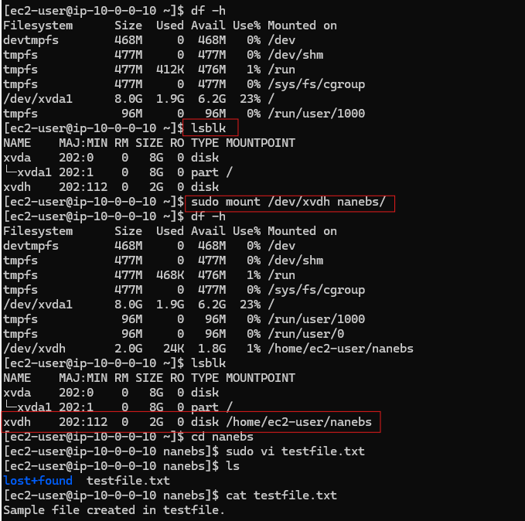

**Step 5: Create snapshot and Volume from snapshot.**

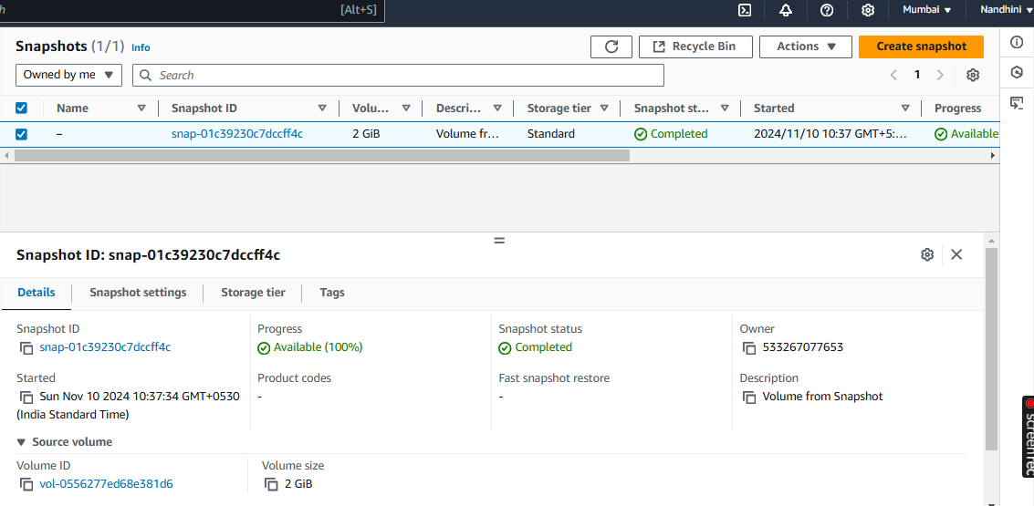

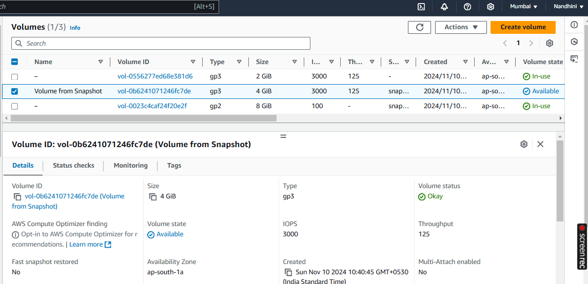

**Step 6: Detach old volume**

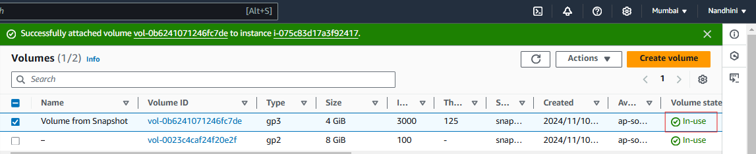

**Step 7:** **Attach volume created from snapshot to the instance.**

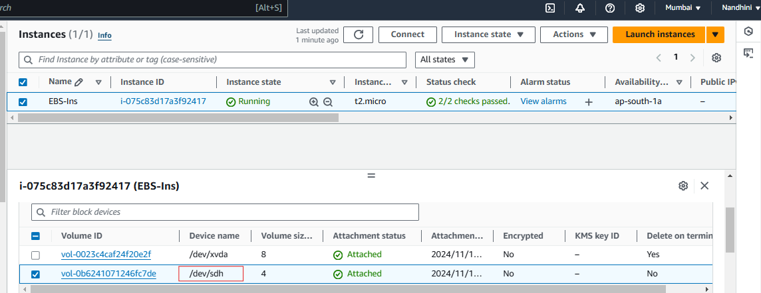

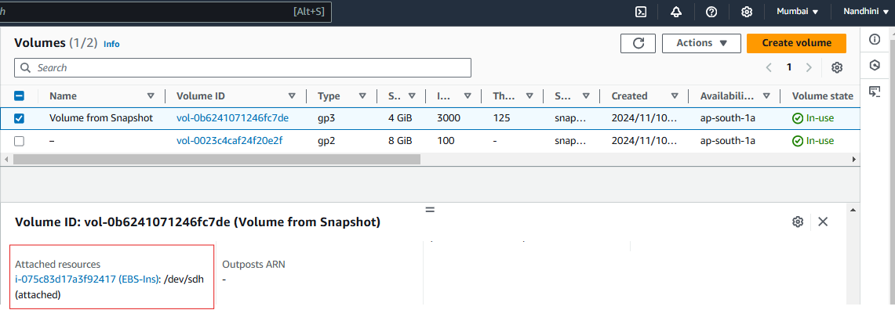

**Step 8: Login to the EBS instance and create new folder mount volume created bysnapshot. Now I can able to view two folders and file created in old volume.**

